**WEB PROGRAMMING-1**

**HTML PRACTICE QUESTIONS**

**1_)**

**Design a webpage (home.html) with the following features:**

a. Display your name in **blue color** using the **Verdana** font on the screen. Set the webpage title as:  
**"Welcome to my page - [Your Registration Number]"**

b. Print alphabets from **A to F** on the screen from **smallest to largest font**, each letter styled with a different **font and color**.

c. Display your first name in **bold**, middle name in **italics**, and last name in **underlined** font format.

d. Write and display **two paragraphs** that describe your ambition and hobbies:

* Highlight the **ambition** text with a **yellow background**.
* Italicize and **bold** the hobbies text.

e. Add a **comment line** in your HTML code. Ensure it does not appear on the webpage.

f. Display the following **equations** on the page:

* (a−b)2=a2−2ab+b2(a - b)^2 = a^2 - 2ab + b^2(a−b)2=a2−2ab+b2
* 2H2+O2=2H2O2H_2 + O_2 = 2H_2O2H2​+O2​=2H2​O

g. Display a **C program** that prints your account number and balance (include the ₹ (Rs.) symbol).

h. Set an **image** as the background of the webpage.

i. Apply a **marquee** to display your roll number.

j. Insert a **passport-sized image** aligned to the **right side** of the screen.

k. Use a **<div>** tag to display two separate paragraphs.

l. Create a link at the **bottom of the page** and move from bottom to top **onclick**.

m. Create a **"mailto"** link to any email ID.

n. Use **acronym**, **meter**, **progress bar**, and **summary** tags on your page.

**HTML CODE:**

<!DOCTYPE html>

<html>

    <head>

        <title>

            Welcome to my page-23BCE1426

        </title>

        <style>

            /* Style for the image */

            .passport-image {

                width: 150px; /* Adjust width for passport size */

                height: 200px; /* Adjust height for passport size */

                position: absolute; /* Use absolute positioning */

                top: 50px; /* Distance from the top */

                right: 50px; /* Distance from the right */

                border: 2px solid black; /* Optional: Add border to mimic passport style */

                border-radius: 5px; /* Optional: Add rounded corners */

            }

        </style>

        <style>

            meter {

              width: 300px;

              height: 100px;

              color:aqua

            }

          </style>

          <style>

            progress{

                width: 300px;

                height: 100px;

                color:blanchedalmond

            }

          </style>

    </head>

    <body>

        <!--h-->

        <body style="background-image: url('htmlimage.jpg'); background-size: cover; background-repeat: no-repeat; background-position: center;background-attachment:fixed;">

            <p style="font-size:300%;color:pink">This is my webpage</p>

             <!--a-->

        <h1 style="color:blue;font-family:verdana;text-align:left">

            (a)Sanjana Raghunath.

        </h1>

        <!--b-->

        <p style="font-size:200%">(b)</p>

        <h6 style="color:red;text-align:center;font-size:50%;font-family:Arial, Helvetica, sans-serif">A</h6>

        <h5 style="color:blue;text-align:center;font-size:100%;font-family:'Franklin Gothic Medium', 'Arial Narrow', Arial, sans-serif">B</h5>

        <h4 style="color:blueviolet;text-align:center;font-size:150%;font-family:'Lucida Sans', 'Lucida Sans Regular', 'Lucida Grande', 'Lucida Sans Unicode', Geneva, Verdana, sans-serif">C</h4>

        <h3 style="color:pink;text-align:center;font-size:200%;font-family:'Segoe UI', Tahoma, Geneva, Verdana, sans-serif">D</h3>

        <h2 style="color:greenyellow;text-align:center;font-size:250%;font-family:'Times New Roman', Times, serif">E</h2>

        <h1 style="color:green;text-align:center;font-size:300%;font-family:'Trebuchet MS', 'Lucida Sans Unicode', 'Lucida Grande', 'Lucida Sans', Arial, sans-serif">F</h1>

        <!--c-->

        <p style="color:blueviolet;display:inline;font-size:300%;"><b>(c)Sanjana</b></p>

        <p style="color:blue;display:inline;font-size:300%;"><i>Raghunath</i></p>

        <p style="color:red;display:inline;font-size:300%;"><u>P</u></p>

        <!--d-->

        <p style="font-size:300%"><mark>(d)My ambition is to become a professional singer and an expert data scientist.</mark></p>

        <p style="font-size:300%;color:azure"><i><b>My hobby is singing and writing stories.</b></i></p>

        <!--e-->

        <!--This is a comment line-->

        <!--f-->

        <p style="font-size:200%;text-align:center;background-color:beige">(f)1)(a-b)<sup>2</sup>=a<sup>2</sup>-2ab+b<sup>2</sup></p>

        <p style="font-size:200%;text-align:center;background-color:antiquewhite">2)2H<sub>2</sub>+O<sub>2</sub>=2H<sub>2</sub>O</p>

        <!--g-->

        <pre>

            <code>

                <p style="font-size:200%;text-align:center;color:bisque;background-color:black"></style><b>

                (g)int accountnumber=10238264;

                int balance=50000;

                printf("The account number is:%d",accountnumber);

                printf("The balance amount is:%d",balance);

                </b>

            </code>

        </pre>

        <!--i--><marquee style="color:antiquewhite;font-size:200%;background-color:black">23BCE1426</marquee>

        <!--j--><img src="download.jpeg" alt="Passport" class="passport-image">

        <!--k-->

        <div>

            <p style="color:blue;font-size:300%;"><b>This is the first paragraph</b></p>

            <p style="color:blueviolet;font-size:300%;"><b>This is the second paragraph</b></p>

        </div>

        <!--l-->

        <div>

            <p style="color:blanchedalmond;font-size:300%;background-color:blue">Scroll down to see the "Back to Top" button at the bottom-right corner of the page.</p>

          </div>

          <a href="#top" class="to-top" style="font-size:300%;background-color:yellow">Back to Top</a>

          <br></br>

        <!--m-->

        <a href="mailto:sanjana.raghunath2023@vitstudent.ac.in" style="font-size:300%;background-color:yellow">Send mail</a>

        <!--n--><!--here the abbreviation short form is underlined-->

        <p style="background-color:bisque;font-size:300%">The <acronym title="Wireless Fidelity">WiFi</acronym> is used in all homes for internet connection.</p>

        <h3 style="font-size:300%;background-color:aqua">Disk Usage</h3>

        <meter value="60" min="0" max="100">60%</meter>

        <p style="font-size:300%;background-color:aqua">60% of the disk space is used.</p>

        <h2 style="background-color:antiquewhite;font-size:300%">Download progress</h2>

        <progress value="50" max="100">50%</progress>

        <p style="font-size:300%;background-color:antiquewhite">50% download is finished.</p>

        <details>

            <summary style="font-size:300%;background-color:blue;color:antiquewhite">What is HTML?</summary>

            <p style="font-size:300%;color:blue;background-color:bisque">HTML is Hyper TextMarkup Language which is used as a base to create web pages.</p>

        </details>

        </p>

    </body>

</html>

Webpage URL:

<http://127.0.0.1:3000/c:/Users/SanjanaRaghunath/Downloads/home.html>

Webpage outline:

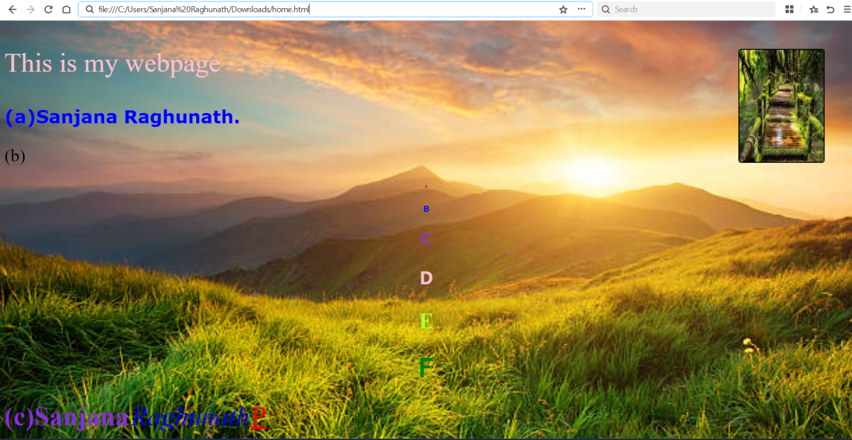

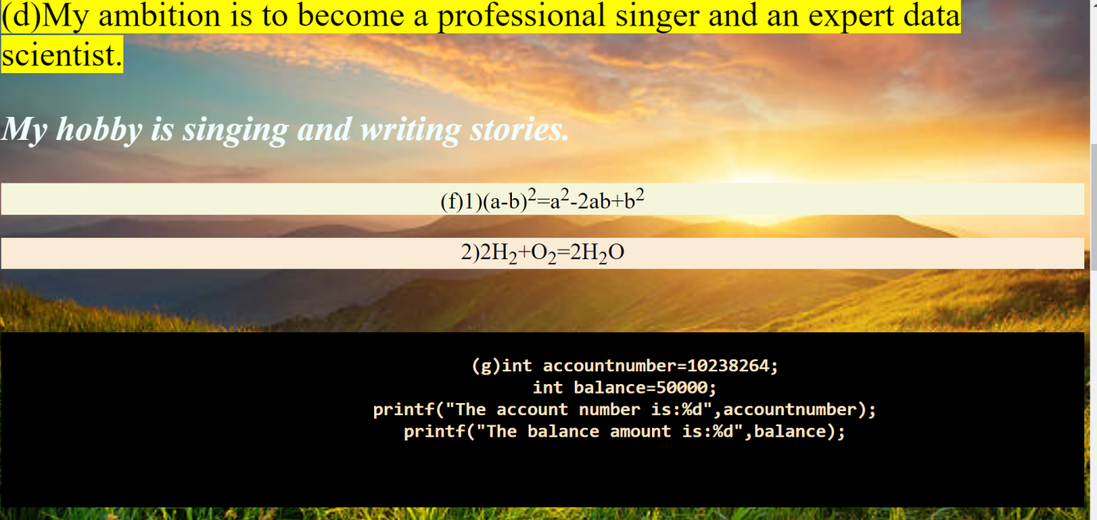

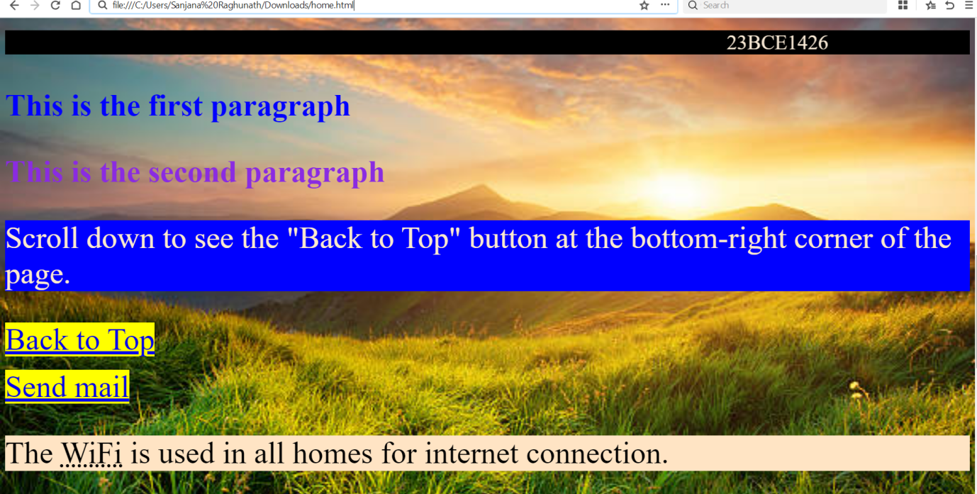

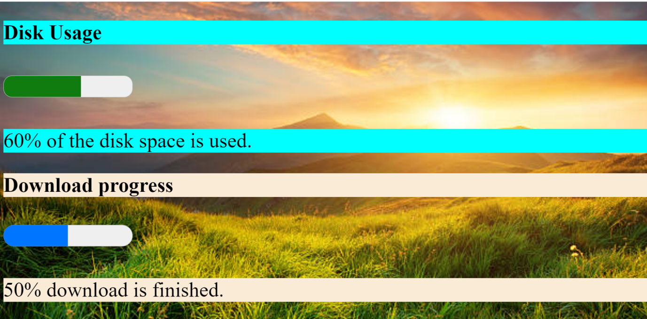

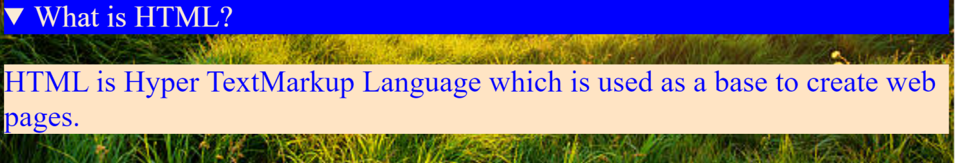

1. design a e greeting card

<!DOCTYPE html>

<html lang="en">

<head>

    <meta charset="UTF-8">

    <meta name="viewport" content="width=device-width, initial-scale=1.0">

    <title>E-Greeting Card</title>

    <style>

        body {

            font-family: Arial, sans-serif;

            margin: 0;

            padding: 0;

            display: flex;

            justify-content: center;

            align-items: center;

            height: 100vh;

            background-color: #f0f0f0;

        }

        .card {

            max-width: 500px;

            text-align: center;

            background: white;

            border-radius: 100px;

            box-shadow: 0 4px 8px rgba(0,0,0,0.1);

            padding: 20px;

        }

        header {

            font-size: 2rem;

            color: #333;

        }

        main {

            margin: 20px 0;

        }

        footer {

            margin-top: 20px;

            font-size: 1rem;

            color: #555;

        }

    </style>

</head>

<body>

    <body style="background-image: url('diwali.jpeg'); background-size: cover; background-repeat: no-repeat; background-position: center;background-attachment:fixed;"></body>

    <section class="card">

        <header>

            <h1 style="color:red"><u>Happy Diwali!</u></h1>

        </header>

        <main>

            <img src="diw1.jpeg" alt="diwali">

            <p style="background-color:aqua;color:black"><b>Wishing you joy, peace, and happiness this festival season!</b></p>

            <p style="color:red"><b><mark>Enjoy every moment with your loved ones.</mark></b></p>

            <p style="background-color:antiquewhite;color:blueviolet"><b>Celebrate the festival of lights with all happiness and safety.</b></p>

        </main>

        <footer>

            <p style="font-family:Arial, Helvetica, sans-serif">From, Sanjana</p>

        </footer>

    </section>

</body>

</html>

Output:

